Subject: Bonus Leave - 2017 scheme vs 2026 policy, and tracker correction
Hi Graham,
In our meeting we agreed that the only change from the 2017 scheme to the 2026 policy should have been that Bonus Leave is no longer paid out on termination. When I compared the 2017 flowchart (CTS Additional Leave Bonus Scheme v1.0, announced 27/11/2017) against the 2026 policy, the 2026 wording changes more than that. The tracker is built on the 2026 policy as written, with one correction we agreed in the meeting: nobody counts service before the scheme started on 27/11/2017, so everyone employed before that date is treated as commencing on 27/11/2017 and we do not count back. Below is each difference with the two documents side by side, what the tracker currently does, and where I need your decision.
1. Who is eligible
2017: full-time employees only.
2017 flowchart
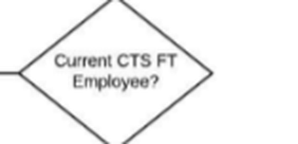
2026: part-time employees on 24 or more hours a week are now eligible, from 5 years' service.
2026 policy, Scope (page 3-4)
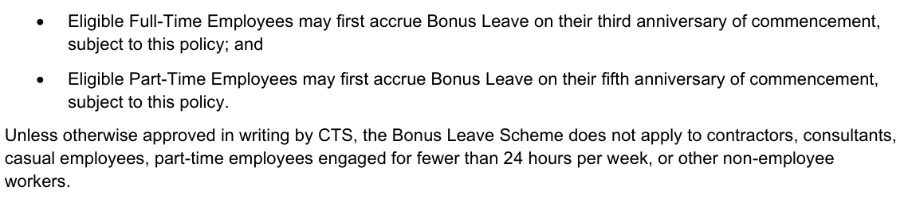
Tracker: follows 2026. Isaac Butterworth's part-time service from 17/09/2019 (38 hours) counts, which gives him 9 days, the same as the HR tally. Tyrell Shortt (part-time, 38 hours) earned his first day on 31/08/2026. If you decide the 2017 rule stands, both drop out: Isaac's first day would then be 19/01/2029 and Tyrell would not be eligible.
2. The 5-year anniversary
2017: one day on the anniversary, then one day every three months (two days only from the 6-year anniversary).
2017 flowchart, 5 years or more
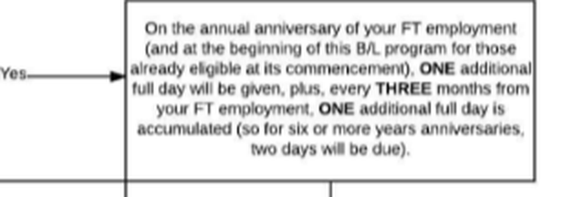
2026: two days on the 5-year anniversary itself.
2026 policy, Accrual Rules (page 5)
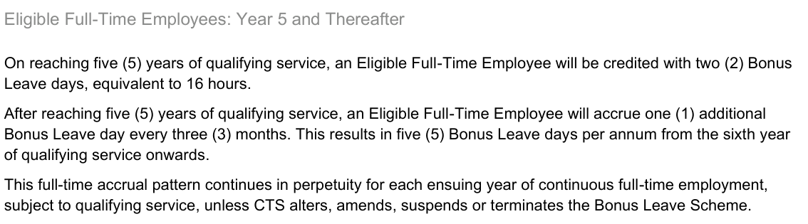
Tracker: one day for anyone whose 5-year anniversary fell before 08/09/2026 (the policy date), two days from then on. This matches the HR tally for everyone who has already passed 5 years.
3. Part-time accrual rate (new in 2026)
2026 policy, Eligible Part-Time Employees (page 5-6)
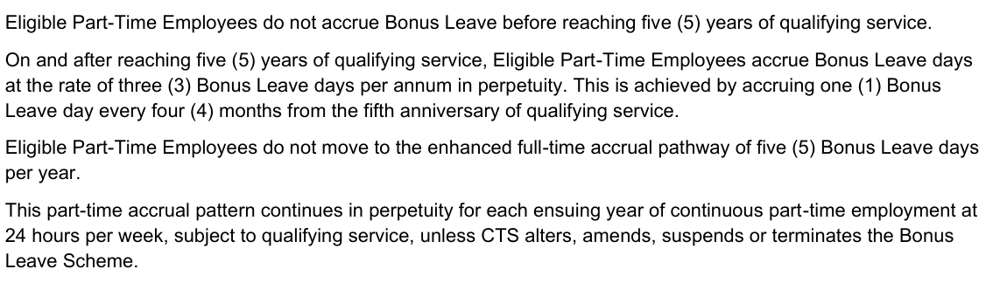
Tracker: applied for part-time staff on 24 hours or more. No part-time employee has reached 5 years yet, so it has not produced any accrual.
4. When service is counted from
2017: from the full-time employment start date, or the eligibility letter date if different.
2017 flowchart, 3 to 5 years
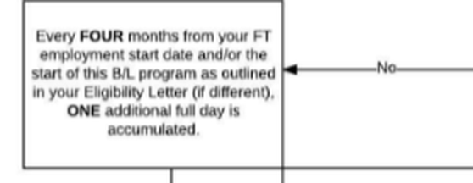
2026: from the original start date with CTS, paused during parental leave or leave without pay.
2026 policy, Definitions (page 3)
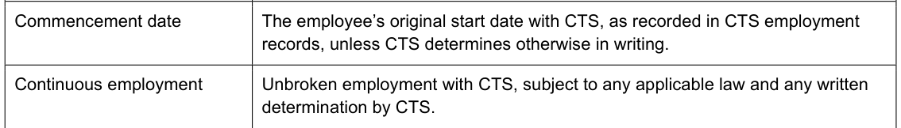
2026 policy, Qualifying Service and Extended Leave of Absence (page 5)
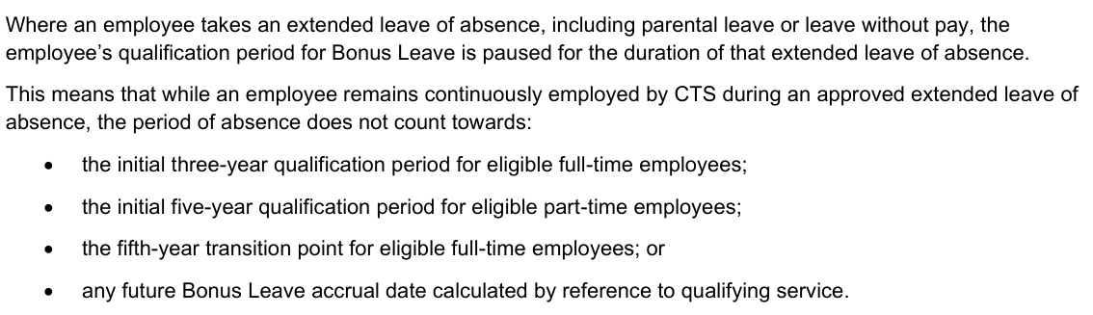
Tracker: service counts from the first full-time or part-time start date (casual time never counts), or from 27/11/2017 for anyone employed before the scheme began. Nothing is counted back before the scheme start, so those staff reach 3 years on 27/11/2020 and 5 years on 27/11/2022. Parental leave and leave without pay are not yet paused in the tracker; let me know if any current staff have had an extended absence.
On this basis Daniel Sobkowski, Duncan Lugstein and Jordan Sexty were credited from their original anniversaries under the old tally and now hold more in EH than their entitlement: Daniel 40 hours, Duncan 160 hours and Jordan 64 hours over. I checked Daniel's and Jordan's personnel files and could not find an eligibility letter for either of them, yet HR accrued for them from 2017. I need your decision on whether that excess stands as granted or is reversed.
5. Termination (the agreed change)
2017: Bonus Leave accrued more than a year before termination was paid out.
2017 flowchart, leaving CTS
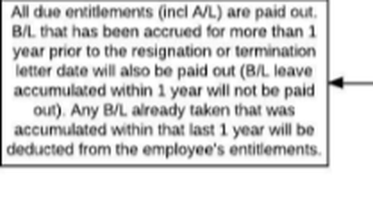
2026: all unused Bonus Leave is forfeited, nothing paid out.
2026 policy, Termination of Employment (page 8)
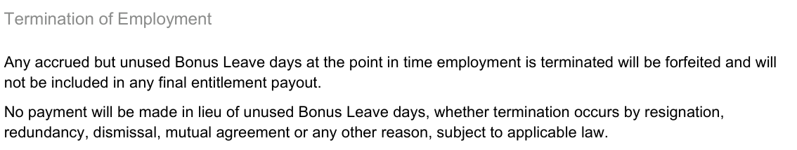
Tracker: leavers are removed and their EH balance zeroed.
Everything else is the same in both: first day at 3 years, one day every four months to year 5, five days a year after that, no pro-rata, and nothing before the scheme start on 27/11/2017.
Decisions I need from you: (1) confirm the 2026 policy applies as written, including part-time eligibility and two days at 5 years, or tell me only the payout change was intended, in which case I flip one switch in the tracker and Isaac and Tyrell come off the list; (2) whether the excess hours for Daniel, Duncan and Jordan stand as granted or are reversed. The eligibility letters I listed in my earlier email still stand.
Thanks,
Danica

